Unit

The Unit script is a very short compared to the first tutorial. It holds information for the stats of the characters and can be applied to every character, player or NPC that is going to take part in the game. It holds information about the Name of the character, Level, amount of Damage that this character can apply, the Maximum Hit Points and the Current Hit Points.

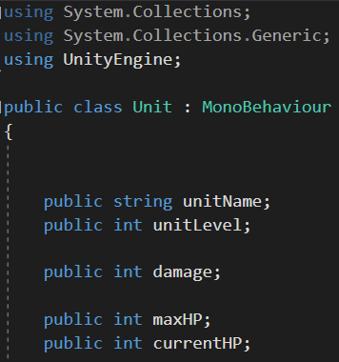

The next lines create a condition about receiving Damage, that simply says take the amount of damage out of the amount of Hit Points and if the Current amount of Hit Points is equal or less than zero return as false.

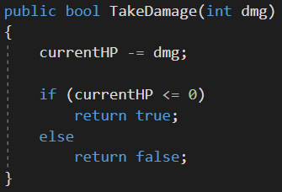

And also a statement for the Heal function created in the first tutorial, that says add the Heal amount to the Current Hit Points, But if the Current Hit Points try to exceed the maximum amount of Hit Points, then make them equal to the maximum Hit Points.